he CAN-SPAM act requires that Commercial emails, whose primary purpose is to deliver commercial content, meet the following criteria:

* Accurately identify the sender in the header information.
* Use a subject line that accurately represents the content of the email.
* Identify the message as an advertisement unless you have express consent (opt-in) from the subscriber.
* Include your physical mailing address.
* Provide a mechanism to opt-out. You cannot require a subscriber to log in or visit more than a single page to unsubscribe.
* Honor opt-out requests promptly. You must process an unsubscribe request within 10 days, and your unsubscribe mechanism must be operational for at least 30 days after the mailing.

**Email Studio**

With Email Studio, build and send personalized email from basic newsletters to the most complex campaigns. Deliver promotional, transactional, and triggered messages. Track and optimize to drive performance.

6 tools:

* [**Content**](https://help.salesforce.com/s/articleView?id=sf.mc_es_content.htm&language=en_US&type=5)  
  Create content for your emails and send your emails use Email Studio content creation tools. Create reusable content blocks, including text, HTML, images, buttons, dynamic content, and A/B testing, to ensure that relevant messaging reaches the right person every time.
* Below Image with 3 tools:

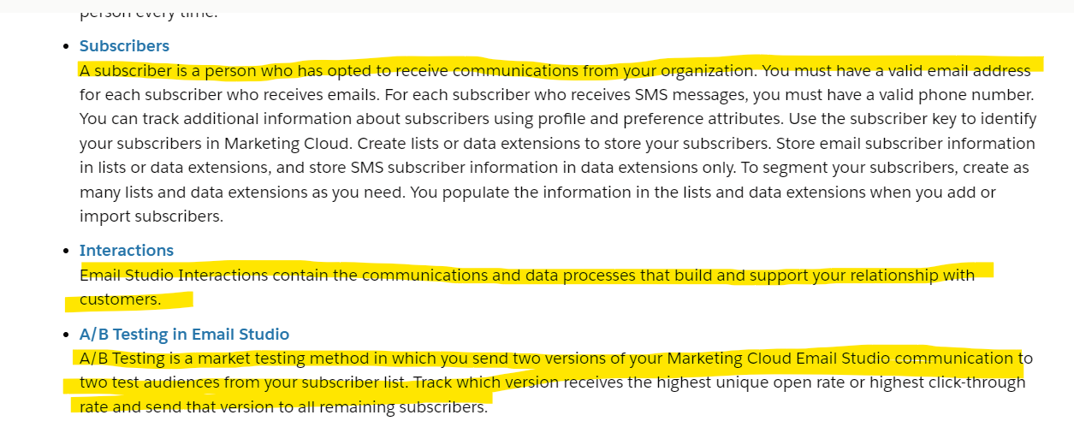

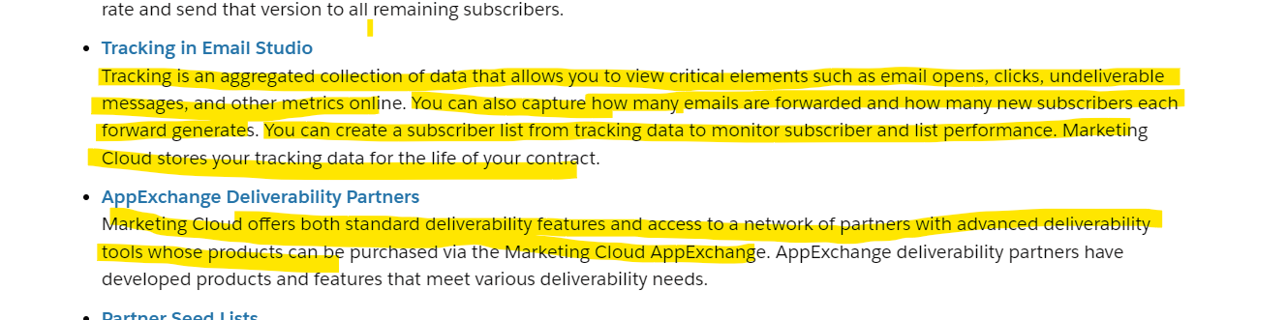

Main Roles:

Mc Administrator,

channel Manager,

content editor/Publisher,

Viewer

Sec Administrator

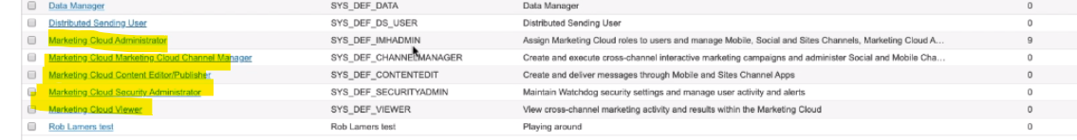

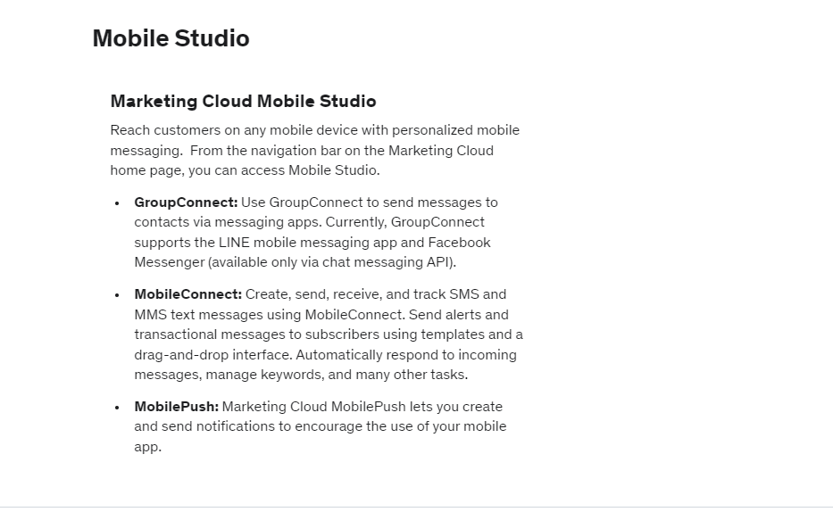

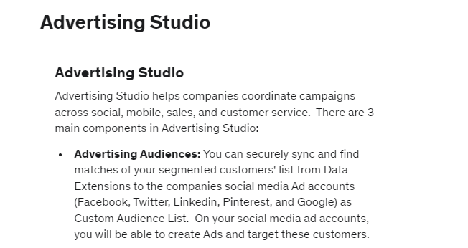

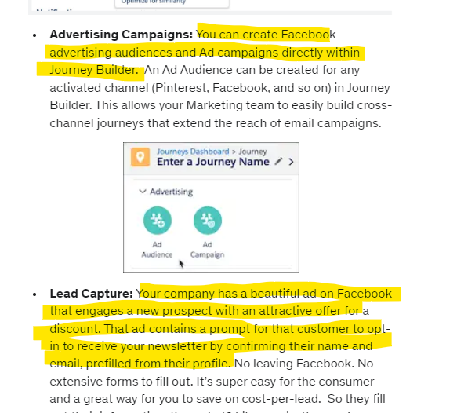

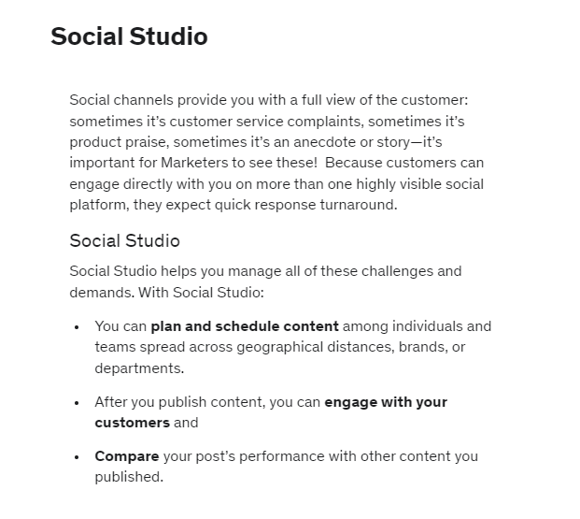

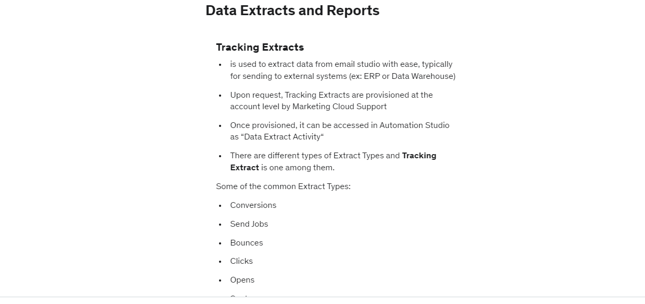

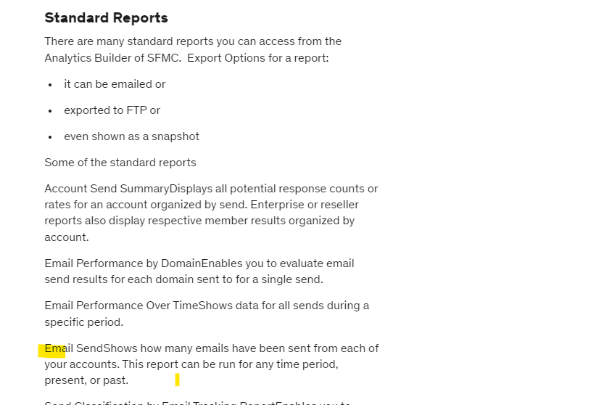

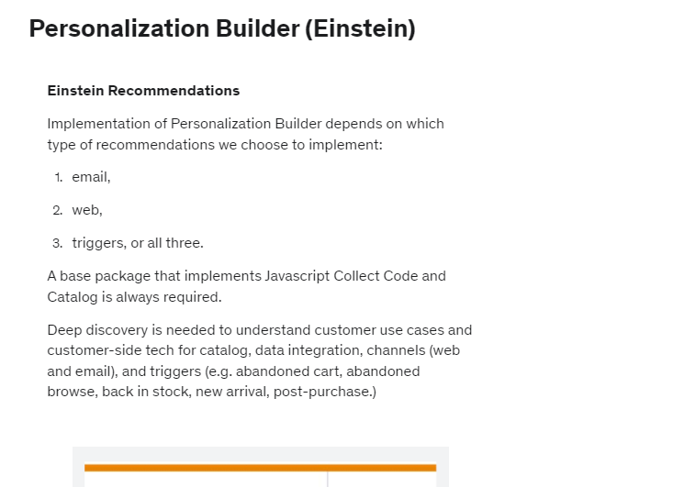

Datoroma:

